Christian Wendlandt

Professor George Thomas

Computer Science 361

15 March 2018

Assignment 1

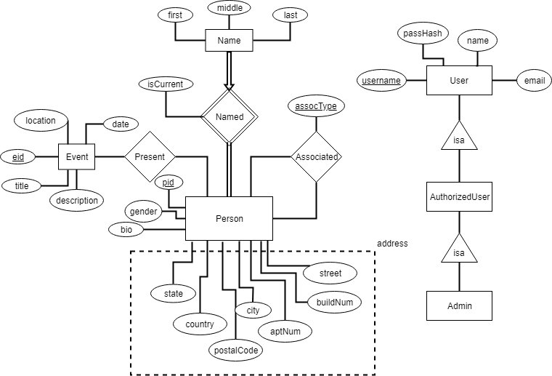

|  |  |
| --- | --- |
| Entity or Relation Name | Description |
| Person | Represents a family member in the database. Each person has a person ID (pid), as well as a plethora of optional attributes; including a last known address and gender. |
| Name | Represents a unique person’s name (not that the names are unique.) Made up of the person’s first, middle, and last name. |
| Named | Represents the link between a person and the names they have used. Their current name is flagged with “isCurrent”. |
| Event | Represents any and all events that are worth recording. Events can exist without anyone present from the database. For example: The battle of Waterloo is put into the database but the database may not yet contain someone that was present during it. Described by an event ID (eid), a title, a location, a date, and a description. |
| Present | Represents the link between an event and persons from the database. |
| Associated | Represents an association between two persons in the database. Associations are unidirectional by default. For example: “Vader is Luke’s father” is an association. “Luke is Vader’s son” is a different association. |
| User | Represents a user with an account on the site. Attributes include their username, password hash, name, and email. Has READ privileges. |
| AuthorizedUser | Contains same information as “User”, but these accounts have READ and WRITE privileges. |
| Admin | Contains the same information as “User”, but these accounts have READ, WRITE, and ADMIN privileges. |

Person(pid, gender, bio, country, state, city, street, buildNum, aptNum, postalCode)

Name(Person.pid, isCurrent, first, middle, last)

Association(Person1.pid, Person2.pid, assocType)

Event(eid, title, location, date, description)

Present(Event.eid, Person.pid)

User(username, passHash, name, email)

AuthorizedUser(username)

Admin(username)